REPORTING DASHBOARD SPECIFICATION
CX Measurement and Monitoring Reporting Dashboard

1. Dashboard Specification

1.1 Overview
Purpose | To show how customers rate the service, where the weakest points are, and whether follow-up is being completed
Primary users | CRM agents daily for detractor follow-up; Workshop Managers weekly; General Manager monthly
Refresh | Live as survey responses are received
Filters | Reporting period · branch · service line · channel · customer segment
Export | Excel and PDF

1.2 Panels
Panel | What it shows | How it is calculated | Drill-down
Headline tiles | Net Promoter Score, CSAT, Customer Effort Score and resolution rate | Calculated from responses received in the selected period | Tile opens the underlying responses
Response volume | Responses received, surveys issued and the response rate | Responses ÷ surveys issued | Opens the response list
NPS breakdown | Promoters, passives and detractors as a share of responses | Promoters less detractors, on a scale of −100 to +100 | Segment opens the responses in that band
Question-level scores | Average score for each of the nine survey questions | Mean score per question | Question opens the responses and comments
Results by branch | Each measure shown by site, ranked | Same calculation, filtered by branch | Branch opens that site's dashboard

2. Screen Captures
2.1 Dashboard home - headline measures with response count
Capture with the period and branch filter visible; the response count must be legible.
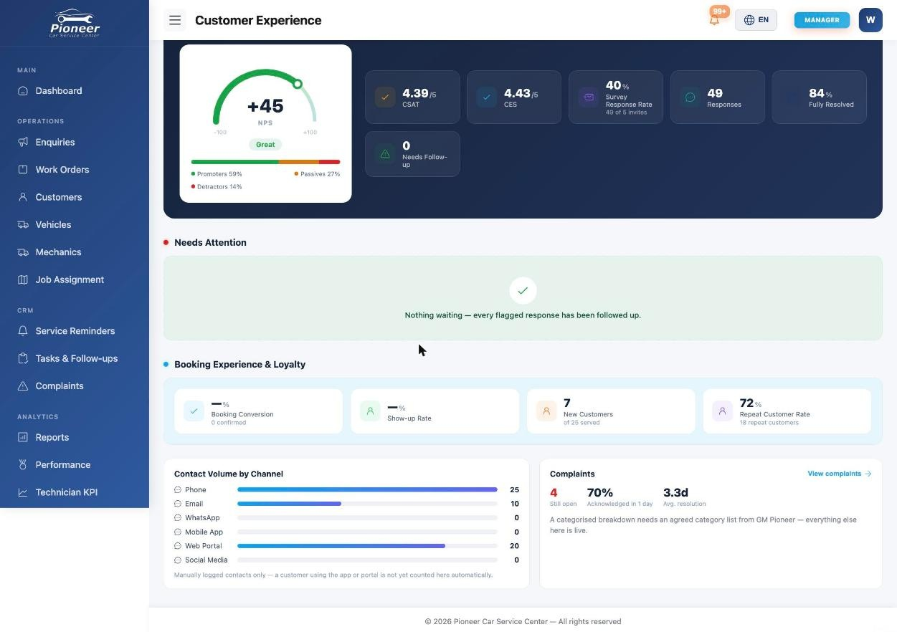

2.2 NPS breakdown
Show promoters, passives and detractors.
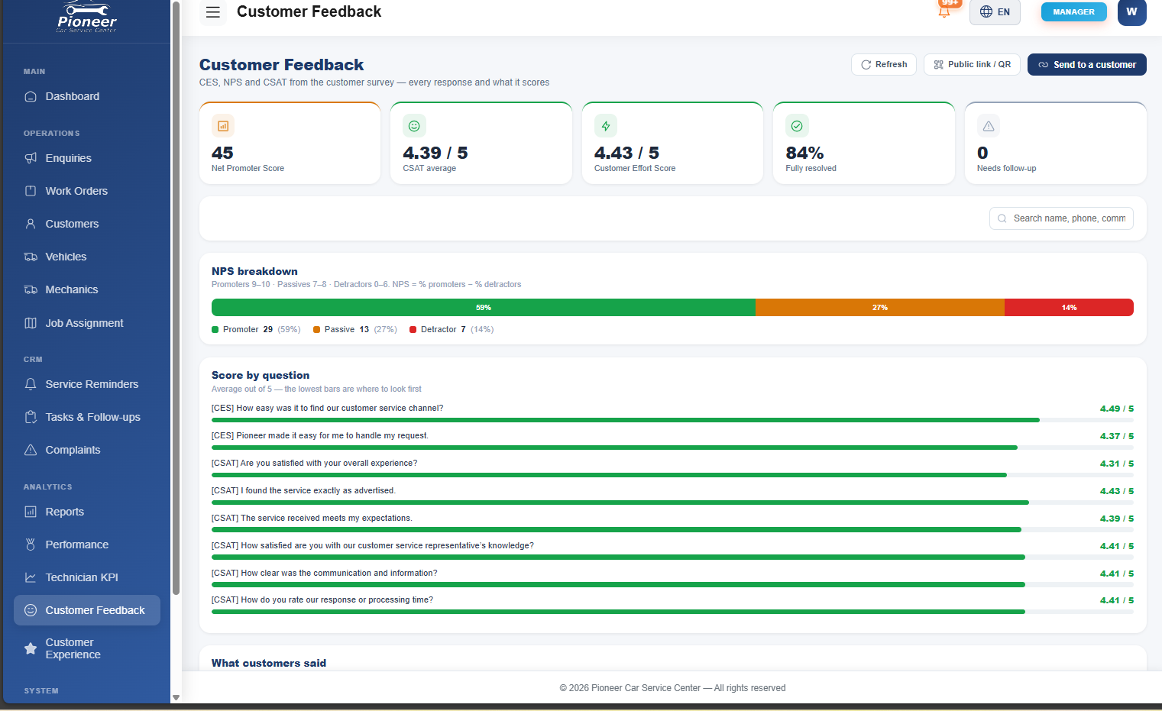

2.3 Question-level scores
Show all nine questions, with the two effort questions identifiable.
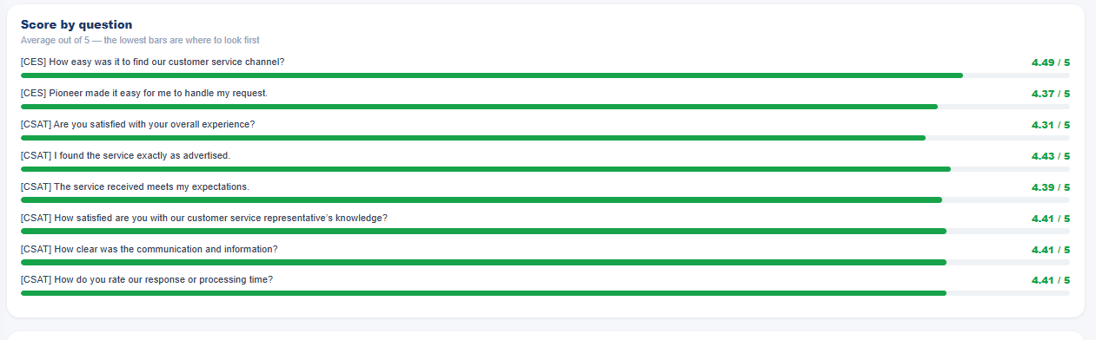

2.4 Results by branch
Show each measure by site for the same reporting period.
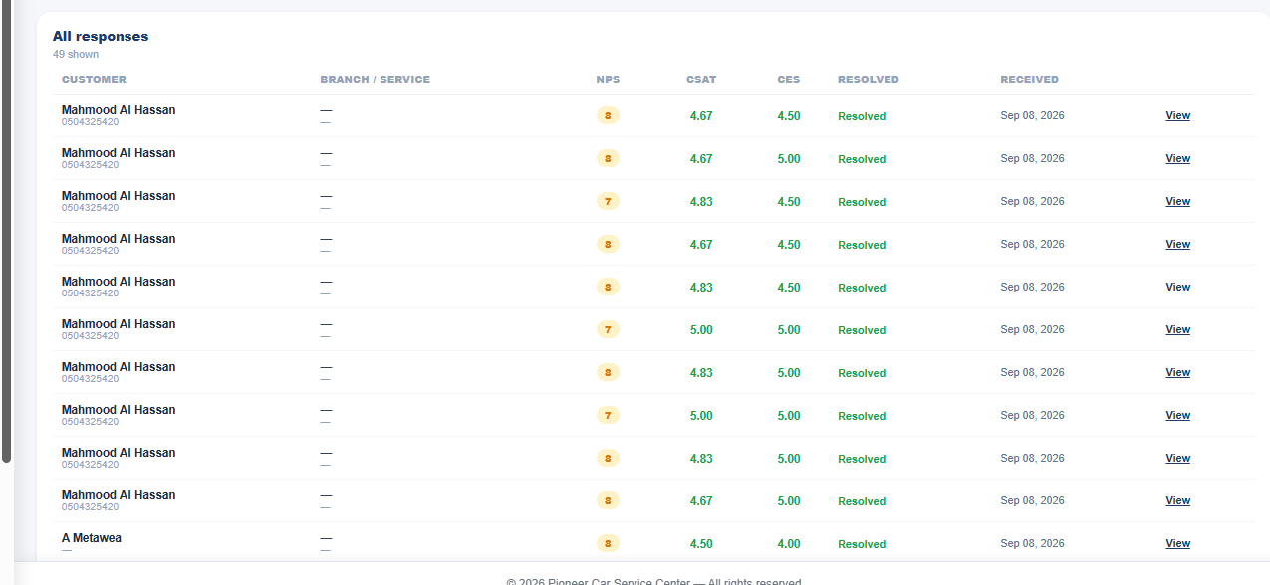

2.5 Monthly customer experience pack
Show the export screen and the resulting pack.
